Investment Strategy

ACCT656 – ACCT 656 Analytics for Value Investing

Group Project 2024

Zhang Jiaxiang 01492343

Zong Yulin 01477707

Yang Wentao 01496431

Li Jia 01477715

Chern Cheng 01354502

**Grading criteria**:

- Report(Research and statistical methodology,including interpretation of

results) (55%-60%)

- Presentation (20%)

Not exceeding 10 pages

1.5 space

normal margin

12 times new roman

Contents

**1.** **Introduction** 2

**2.** **Data Clean / Sample Selection** 2

**3.** **Signals selection** 3

**a)** **Fscore** 3

**b)** **Zscore** 4

**c)** **Safety Margin** 6

**d) V/P ratio** 6

**4.** **Investment Strategy** 8

a) Investment Strategy I 8

i. Trade Strategy 8

ii. Back – Test 8

b) Investment Strategy II 10

i. Long Trading Strategy 10

ii. Short Trading Strategy 10

iii. Back – Test 11

5. **Limitations and Conclusion** 11

**Appendixes** 12

**Reference List** 25

# **Introduction**

Investment strategies are not one-size-fits-all. Value investing has proven its capabilities for sustainable long-term earnings. In this research, we developed several trade signals based on prior papers. As capital markets evolve, and widely used patterns or strategies may lose effectiveness over time. Our selected signals produced results opposite to those in the original papers; for instance, a higher F-score correlated with lower stock returns.

To pursue profit, we developed our investment strategy as such:

1. We reversed hypotheses from past papers, assuming history repeats itself.
2. We adhered to value investing, selecting high-quality stocks using trade signals, regardless of their historical effectiveness, as validated by our data.

# **Data Clean / Sample Selection**

We use three distinct databases for our analysis: 1. Basic Financial Data: Sourced from "Compustat – Fundamental Annual," this includes 24,739 rows of data used to calculate intrinsic value, Z-score, and F-score, indicating financial health and performance. 2. Value Forecasting Data: From the "IBES" database, this data forecasts the value-to-price (V/P) ratio for the next three years, offering insights into future stock performance and valuation. 3. Stock Monthly Data: Sourced from "CompStat – Security Monthly," this includes 471,832 rows detailing monthly stock prices for analyzing return and volatility.

Our data is divided into strategy sources and consequence sources. To ensure accuracy, we use a validation rolling mechanism based on the data year. This considers the actual date when investors receive financial data and uses future stock performance for back testing our investment strategy. For instance, if a company issues its 2006 financial statement on June 30, 2007, we use the stock return period from June 30, 2007, to July 1, 2008, for analysis. This results in a half-year gap between financial performance and stock return periods. Due to the unavailability of timely stock prices for June 2024, we end our stock price period in 2023. Hence, the financial performance period spans 2007 to 2022, and the stock return period is from 2008 to 2023.

For preprocessing, we: 1. Checked for missing values and statistical features annually and by industry, noting a right-skewed distribution. 2. Filled missing values at the company level using existing data due to the small volume of missing data. 3. Considered but abandoned filling missing values by industry medians due to sufficient data volume for portfolio analysis. 4. Dropped all rows with missing values, resulting in 105,423 rows of complete data. This comprehensive approach ensures a consistent and accurate framework for evaluating our investment strategies.

# **Signals selection**

# **Fscore**

Piotroski’s F-score is a financial metric used to assess a company's quality based on nine criteria across three categories: profitability, leverage and liquidity, and operating efficiency. It is primarily applied to companies with a high book-to-market (BM) ratio to identify fundamentally strong firms that might be undervalued. For our research, we filtered the top 20% of companies with the highest BM ratios.

Table 4.1 details the resulting F-scores. We also calculated the average annual return for each F-score and market value log-transformed (logmv) as shown in Table 4.2. Table 4.3 presents a pivot table of F-scores and market values, showing annual returns. The returns vary across different F-scores and market value deciles, indicating inconsistent performance. We selected F-scores of 2 and 7 to represent low and high F-scores, respectively, and created a comparative line chart in Figure 4.1. This chart shows that companies with lower F-scores tend to have higher overall returns.

To further explore the relationship between annual returns and the F-score, we performed a regression analysis, presented in Table 4.4. The results show a negative correlation, though not statistically significant, contrary to expectations that higher-quality stocks yield higher returns. Similar trends were noted by Woodley for high BM companies from 1997 to 2008, suggesting a possible shift in the F-score's impact over time, though no unified explanation exists for the negative correlation.

Since there is no visible pattern, we plan to modify the F-score by analysing and retaining components with high correlation and replacing some components with alternative ratios, while maintaining the original structure in creation of a new F-score 2. Multivariate and univariate regression analysis were conducted to determine the relationship between individual F-score components and returns. Table 4.5 shows the multivariate results, while Table 4.6 shows the univariate results. Significant variables include asset turnover (multivariate) and accruals, leverage, and stock issuance (univariate). These variables will be retained as components for computing F-score 2.

We explored several alternative variables and generated a correlation heatmap (Figure 4.2) to avoid highly correlated selections. The final selection for F-score 2 is presented in Table 4.7. We calculated the average annual return for each F-score 2, as shown in Table 4.8. Despite an unclear overall pattern, the highest score showed an exceptionally high return. A 10 by 10 decile on returns with logmv and F-score2 is presented in Table 4.9. Notably, the smallest companies with the highest F-score 2 achieved a nearly 90% return, though this result requires further validation due to the small sample size.

# To validate the relationship, we conducted another regression analysis, shown in Table 4.10. The higher p-values indicate that F-score 2 has an even weaker relationship with returns, making it unsuitable for investment construction. Since both the F-score and F-score 2 show insignificant correlations with returns, we will use the original F-score. Despite its negative correlation, F score demonstrates a relatively better relationship and will be used for our future investment strategy.

# **Zscore**

The Altman Z-score evaluates a company's profitability, liquidity, solvency, and activity ratios, serving as a robust predictor of bankruptcy and identifying financially sound companies. According to Altman, companies with Z-scores below 1.81 are at higher risk of financial distress or bankruptcy. Thus, we hypothesize that companies with higher Z-scores, indicating stronger financial health and sustainable earnings, are associated with higher quality. Our hypothesis is that **there is a positive relationship between Z-score and annual stock returns**.

Table Z-1 shows that the mean Z-score of firms in our data is 6.23, with a first quartile of 2.67 and a median of 3.87. All three values exceed Altman's distress threshold of 1.81, indicating strong financial health for most companies listed on the American Exchange over the past 15 years. However, the high standard deviation of the Z-score suggests significant variability, likely reflecting challenges in maintaining financial stability during critical events such as the 2008 financial crisis, the 2009-2011 European sovereign debt crisis, and the 2023 bank failures.

* **Z score vs Markt size - Return**

We created a 10x10 matrix to correlate Z-scores with market size (log of market size) to analyse patterns in annual stock returns. The initial hypothesis was that stock returns would increase with higher Z-scores. However, Table Z-2 did not show any consistent trends. Graph Z-1 reveals numerous outliers with extreme high Z-scores, possibly affecting the results. Observing that Z-scores increase with market size, we truncated companies with Z-scores above 5 and reanalysed the matrix (Table Z-3). This revised analysis also fails to support the initial hypothesis, instead suggesting a negative trend where lower Z-scores yield higher returns. Specifically, companies with the lowest Z-scores in the smallest market size group generated the highest annual stock return of 23.24% (Table Z-2), and the largest company within the lowest Z-score group achieved the highest return of 22.27% (Table Z-3).

* **Z label vs Markt size - Return**

Additionally, we applied Altman’s criteria to classify companies into three groups: distress zone (Z-score below 1.81), grey zone (1.81 < Z-score ≤ 2.67), and non-distress zone (Z-score > 2.67). Despite these categorizations, both Table Z-4 and Z-5 failed to substantiate our hypothesis. Similarly, they indicate that higher stock returns are observed from companies categorized in the distress zone.

* **Regression Analysis**

To examine the negative trend observed meticulously and firmly refute our hypothesis, we conducted a regression analysis to investigate the relationship between the Z score or Z label and stock return. The results of the regression(Z-2) indicate that the Z score is statistically significant (p-value <0.05), but negatively correlated (coefficient -0.0009) with stock return. The company in the Distress Zone is statistically significant (p-value <0.05) and positively correlated (coefficient 0.1518) with the Z score (Z-3).

# **Safety Margin**

The safety margin helps investors assess an asset's value by comparing its intrinsic value to its market value. An undervalued stock generally has safety margin value in the range of 33% - 50%. Table 4.11 shows descriptive statistics for Enterprise Value (enterprise_v) and Intrinsic Value (going_firm_v). The mean enterprise_v is 5584.97 with a median of 2451.94, indicating a right-skewed distribution and a standard deviation of 7014.49. For going_firm_v, the mean is 14919.39, significantly higher than the median of 2027.51, indicating a highly right-skewed distribution with a standard deviation of 631356.22.

Table 4.12 provides insights into the calculated Safety Margin. The mean safety_margin_proxy_ev is -4.48 with a median of -2.33, indicating a left-skewed distribution and a standard deviation of 6.24, suggesting data dispersion. For safety_margin_proxy_iv, the mean is 1.88 and the median is -0.25, indicating a right-skewed distribution with a standard deviation of 46.16, highlighting significant outliers or extreme values.

* **Decile Matrix Tables**

The decile matrix presented in Table 4.13 shows no clear relationship between logmv_win and safety_margin_proxy_ev. However, within certain segments, as logmv_win increases, safety_margin_proxy_ev tends to decrease slightly, suggesting a mild negative relationship in those particular cases. This conclusion similarly applies to the relationship between logmv_win and safety_margin_proxy_iv (Table 4.14), where a slight negative correlation can be observed in certain columns.

* **Hypothesis**

# Our literature review suggests that a higher safety margin, especially in smaller companies, tends to correlate with better performance. However, our data-driven analysis, including OLS regression, shows a negative coefficient and an insignificant p-value. This indicates that the safety margin may have limitations in practical application

# **d) V/P ratio**

V/P ratio measures a company’s intrinsic value based on Residual Income Method (Edwards-Bell-Ohlson valuation technique) as prescribed in *R. Frankel, C.M.C. Lee (1998).* The paper suggests Equity Value can be split into 2 components namely Capital Invested (Book Value) and the present value (PV) of future discounted cash flow not captured in book value. This means if firms create future earnings at a rate equals to its cost of capital (i.e. neither wealth creating nor destroying relative to its shareholders equity), it is only worth its current book value. There are 3 forms of firm’s fundamental value presented in the paper is shown in Table 4.13.

The first equation represents fundamental value with current book value + PV of discounted cash flow with 1 year into perpetuity. The 2nd equation represents current book value + PV of discounted cash flow with 2 years into perpetuity. The same is for 3rd equation except for 3 years into perpetuity. We computed cost of equity using S&P 500 and risk-free rate from Yahoo Finance. Using 2 years of Analyst EPS forecast downloaded from IBES database, we computed all 3 fundamental values to price ratios.

* **Statistic description**

The density plots of the 3 fundamental values are shown in Table 4.14. The values for VP2a_ratio (1 year perpetuity), VP2b_ratio (2-years perpetuity) is similar ranging from -2.89 and 0.13 to 5.77 and 6.40 respectively. However, VP3_ratio (3-years perpetuity) has extreme large values ranging from -4.13 to 13.31. Based on value investing knowledge, a reasonable range of B/P for most companies is between 0 and 1, hence, we have used VP2b_ratio as the fundamental value to price in our paper (i.e. like what Frankel and Lee has used in their paper).

* **Decile Matrix Tables**

Table 4.15 is the 10 by 10 decile matrix plotted on annual returns by VP against firm size. There are no clear trends of annual returns increasing with VP ratios. In fact, for large firm size, it seems the annual returns are higher for firms with low VP and high VP only (i.e. at extreme ends). However, using VP in combination with other signals selected proves to be effective in identifying cheap stocks that yields positive alpha returns.

# **Investment Strategy**

# Investment Strategy I

Based on our review of financial theory and statistical analysis, we developed an investment strategy using four variables as signals, evaluating their correlation with average stock returns. Initial tests showed a high correlation between the safety margin and V/P ratio. Hence, we choose the safety margin and remaining variables in our strategy.

We hypothesized that the safety margin (potential value), the F-score (financial quality), and the Z-score (bankruptcy risk) would positively correlate with stock returns. However, our regression findings reflects non-significant positive coefficients for the safety margin against annual returns. Conversely, F-score and Z-score had negative coefficients indicating negative relationships with annual returns, where Z-score is partially significant across different zones.

Applying the regression analysis, we construed our long strategy 1 which comprise of stocks with the highest safety margins and lowest F-scores and Z-scores.

# Trade Strategy

The investment strategy comprises three steps: firstly, selecting stocks with a safety margin exceeding 33%; secondly, identifying stocks with F-score in the bottom 40%; and thirdly, choosing stocks with Z-score in the bottom 20%. This approach is aligned with the understanding that F score is negatively related to average annual return after Piotroski research period as mentioned in Woodley and Jones paper. Generally, stocks with higher distress (low Z-score) tend to have higher returns because the risk associated with holding these distressed firms is already factored into the stock price.

# Back – Test

Table 5.1 compares the performance of our investment portfolio with the S&P 500 index from 2007 to 2022, using Annual Returns, Portfolio Standard Deviation, and Portfolio Sharpe Ratio.

The top graph in Table 5.1 shows that the portfolio generally outperforms the S&P 500 in most years, with significant outperformance in 2009, 2010, and 2022. The middle graph indicates that while the portfolio has higher volatility than the S&P 500 in some years, namely 2008 and 2016, its volatility is comparable or lower in years like 2018 and 2022. The bottom graph illustrates that the portfolio typically has a higher Sharpe Ratio, indicating better risk-adjusted returns, especially in 2010, 2013, and 2016. The portfolio's maximum drawdown is 0%, as it consistently increased from 2008 to 2022, avoiding significant value declines.

Strategy 1 includes a short strategy with an equal-sized hedge portfolio to outperform the S&P 500, using criteria such as a safety margin below 33%, an F-score above 60%, and a Z-score above 80%. This criteria for the short strategy is selected based on the reverse of the long portfolio, creating a balanced hedge portfolio to maximize returns while mitigating risks.

Performance metrics, including annual returns, portfolio standard deviation, and the Sharpe ratio, provide a comprehensive view of the strategy's effectiveness and stability from 2008 to 2022. The long-buy portfolio generally outperformed the S&P 500, with higher volatility as indicated by the standard deviation, and better risk-adjusted returns as shown by the Sharpe ratio.

The maximum drawdown of 68.62% highlights the potential loss risk, reflecting the largest peak-to-trough decline. The hedge strategy balances maximizing returns and minimizing risks through careful stock selection and risk management, showcasing its potential as a robust investment approach.

In conclusion, combining long-buy and short-sell strategies into an equal-sized portfolio reveals contrasting performance. According to Table 5.3, the primary strategy's cumulative return grew significantly from 0 in 2008 to over 200% by 2022, with a notable spike around 2020. Meanwhile, the combined strategy showed more modest growth, with returns steadily increasing but remaining below 50% by 2022. This disparity underscores the primary strategy's higher return potential despite differing risk management characteristics in the combined strategy.

# Investment Strategy II

Investment Strategy 2 is constructed based on the selection of companies that has strong fundamentals. First, a composite score (0-11) is computed using Piotroski’s F score (0-9), Altman’s Zscore (0-1) and Safety Margin (0-1). Altman’s Zscore is used as part of the composite score to filter out companies that are in financial distress. Hence, companies that are financially stable with a Zscore > 2.67 will have a score of 1 and 0 otherwise. Safety Margin is then used to identify underpriced stocks that is lower than its intrinsic value. Firms with a Safety Margin of > 33% are then given a score of 1 and 0 otherwise. To study the relationship between composite score and annual returns, we then constructed a 10 by 10 decile portfolio of annual returns for composite score against VP as well as firm size. However, Table 6.1 and 6.2 exhibits no clear trends on relationship for annual returns between composite score and VP or firm size.

# Long Trading Strategy

Applying the research outcomes from Fama and French (1992), Frazzini (2018) Buffet’s alpha that small firms generate higher returns, we first classified our stocks into small firms (i.e. logmv < = 0.1 quantile), large firms (logmv >= 0.9 quantile) and neutral (otherwise). We then proceed to construct a 10 by 10 decile portfolio (Table 6.4) on annual returns of composite score against VP ratio on small firms only. Based on Frankel and Lee paper, we concluded that a higher VP ratio indicates that the fundamental value of firm is higher than the prevailing firm stock price (i.e. measures cheapness of stock). Hence, in the population of small firms, we then choose the stocks of firm with a high composite score (i.e. composite score >= 0.9 quantile) and high VP ratio (i.e. VP ratio > = 0.9 quantile). Since high composite score represents better quality firms and high VP ratio firms indicates underpriced stocks, we expect alpha returns from this portfolio and will assume a long position on these stocks. Table 6.4 shows that for high VP ratio small firms stocks, the higher composite score tends to generate higher returns

# Short Trading Strategy

For Short Trading Strategy, we did the reverse and select large firms only. In the selected population of large firms only, we constructed a 10 by 10 decile portfolio (Table 6.5) on annual returns against composite score and VP ratio. Since lower composite score (i.e. composite score <= 0.1 quantile) indicates poorer quality firms and lower VP ratio (i.e. VP ratio <= 0.1 quantile), we choose firms that exhibit the above-mentioned traits from our selected large firms as part of our Short Portfolio. However, Table 6.5 shows notable higher returns on Large firms with low composite score and high composite scores trends.

# Back – Test

Subsequently, we perform back test on the Long Short Strategy outlined in Strategy 2 and analyzed the average returns of the Long portfolio as well as the Short portfolio over the period of 2008 – 2023. Each portfolio exhibits alpha returns that outperforms S&P500 except for year 2013 and 2022. For 2013, the Long portfolio performance is poorer compared to S&P 500. A possible explanation could be the European Sovereign Debt Crisis that happened in 2013 and the Covid Pandemic (2022) where good quality firms are generally not performing per expectations. However, we achieve higher average returns in 2013 by assuming a short position over stocks of Large firms with low composite score and low VP ratio. This enables us to hedge the downside risk of holding stocks in the Long portfolio as seen in Table 6.6.

# Limitations and Conclusion

Based on the results of our study, we concluded that Analyst Forecast Earnings, Firm quality through analysis of financials is not fully incorporated in stock prices. This means there are ways to generate abnormal returns through formulating a strategy based on evaluation of fundamentals of a company. However, our paper is subjected to several limitations which could compromised its comprehensiveness and applicability. Firstly, WRDS financial data is incomplete, lacking critical information such as long-term financial liability which is needed for the computation of net operating assets for firms’ intrinsic value. This limitation impairs the robustness of the financial analysis. Secondly, the study does not include private information from firms, which may result in less accurate conclusions. For example, ROE is frequently employed as a surrogate for ROIC . Terminal Growth Rate, which may not fully reflect the actual situation. Finally, the applicability of previous research papers to the current trading period is limited. The findings of earlier studies, such as those by Piotroski (2000), may not be directly applicable to the current market conditions. Conversely, more recent research, such as that by Jones (2018), may offer more pertinent insights. These limitations underscore the necessity for the acquisition of more comprehensive data and the implementation of updated methodologies to enhance the precision and applicability of financial analyses.

# **Appendixes**

Table 4.1

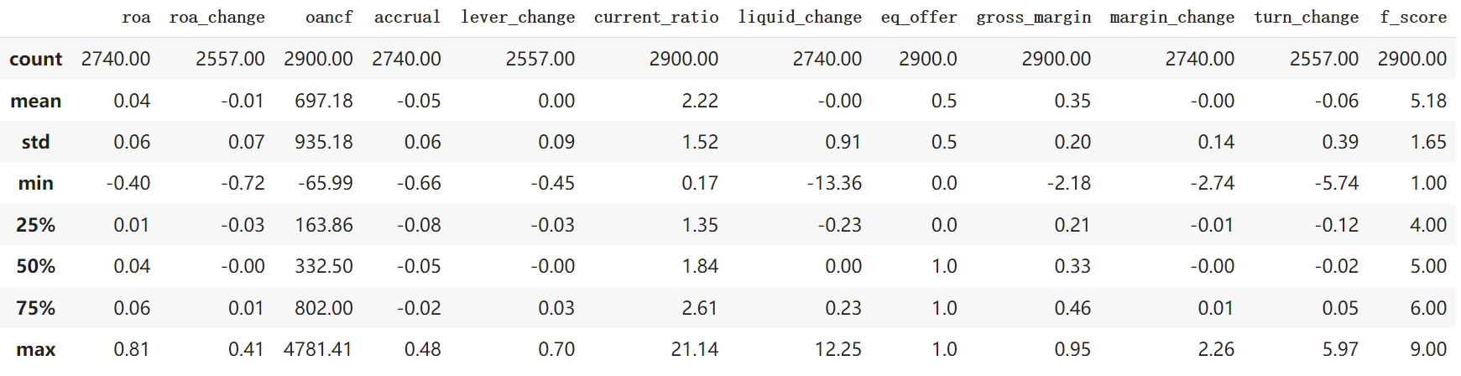

Table 4.2

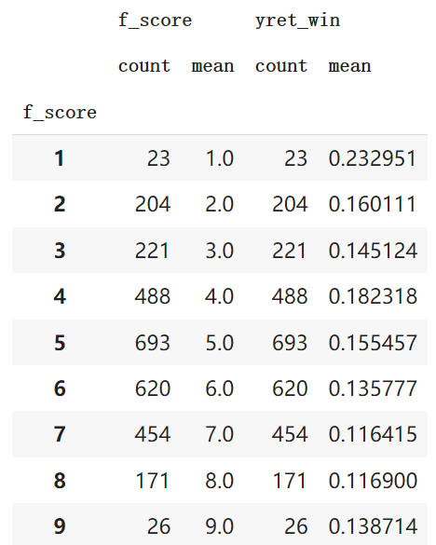 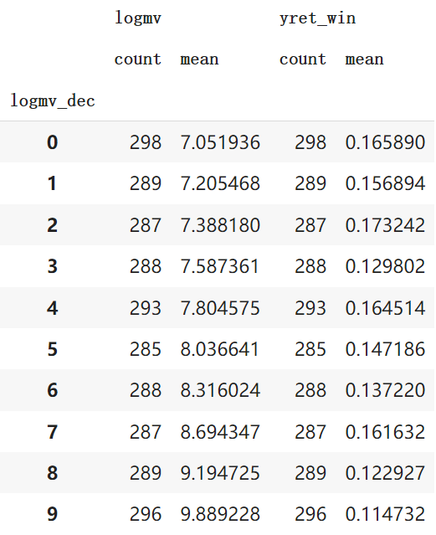

Table 4.3

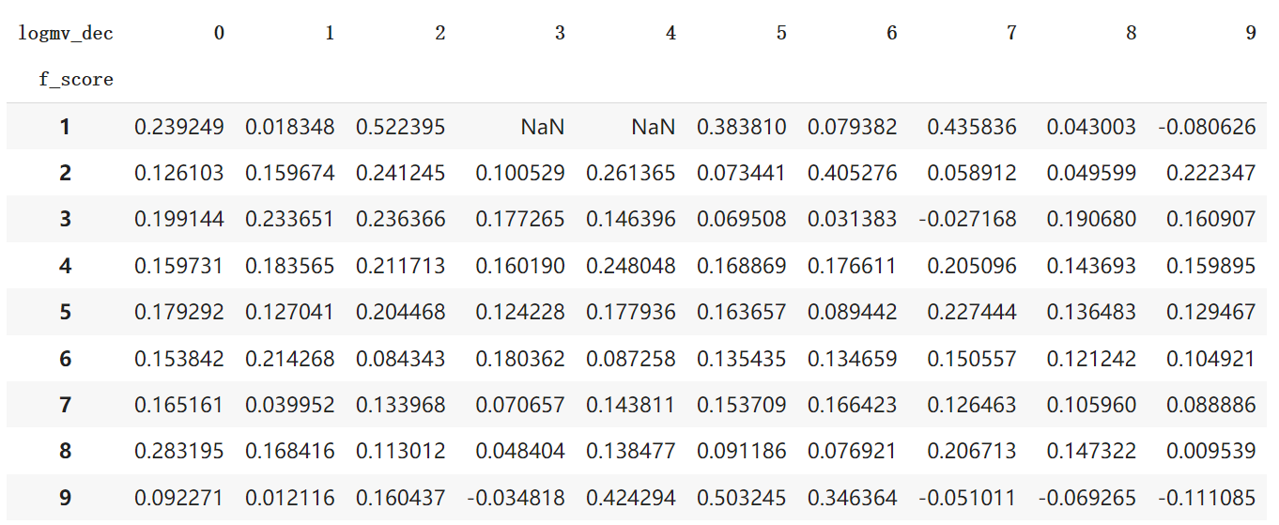

Figure 4.1

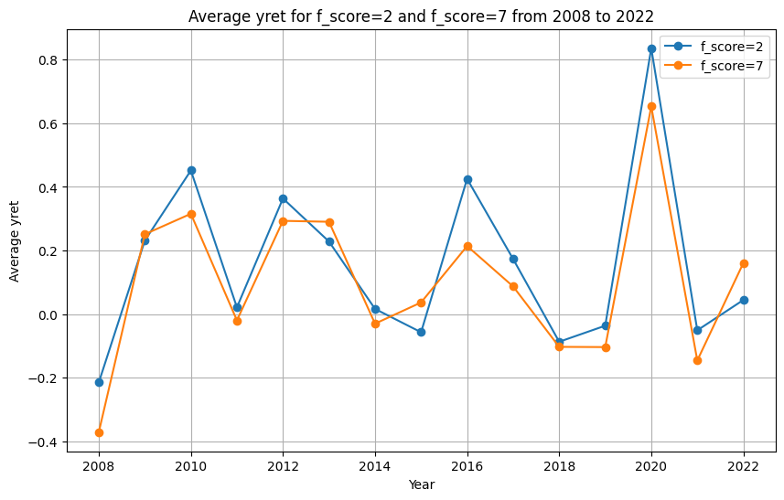

Table 4.4

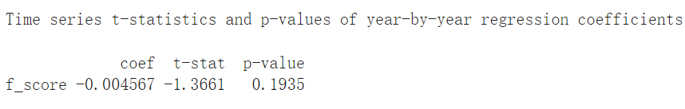Table 4.5

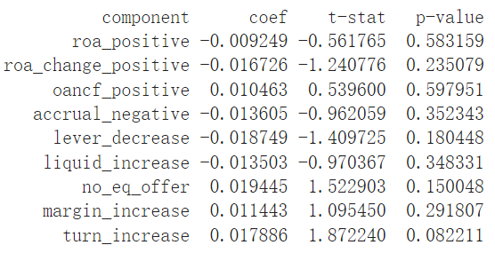

Table 4.6

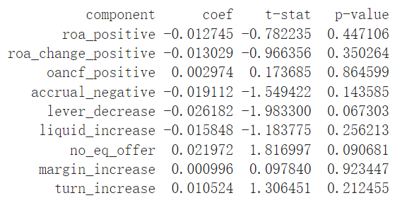

Figure 4.2

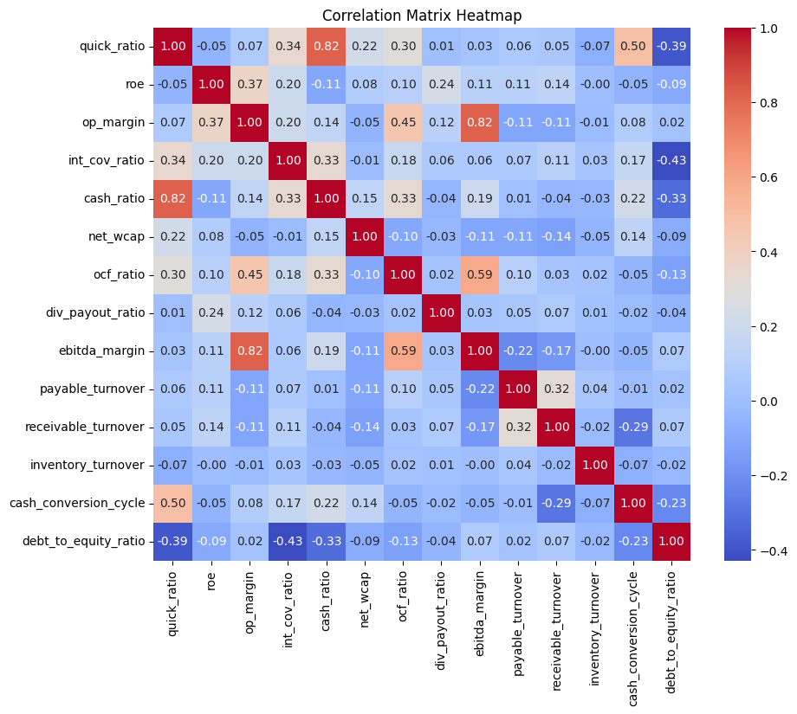

Table 4.7

|  |  |  |
| --- | --- | --- |
| Category | Variable Name | Scoring Condition |
| Profitability | ebitda_margin_increase | Increase compared to last year |
| Profitability | roe_increase | Increase compared to last year |
| Profitability | accrual_negative | Negative accrual |
| Leverage and Liquidity | interest_coverage_ratio | Greater than 1 |
| Leverage and Liquidity | debt_to_equity_ratio | Less than 1 |
| Leverage and Liquidity | net_wcap_increase | Increase compared to last year |
| Operating Efficiency | cash_conversion_cycle_increase | Increase compared to last year |
| Operating Efficiency | payable_turnover_increase | Increase compared to last year |
| Operating Efficiency | div_payout_ratio_increase | Increase compared to last year |

Table 4.8

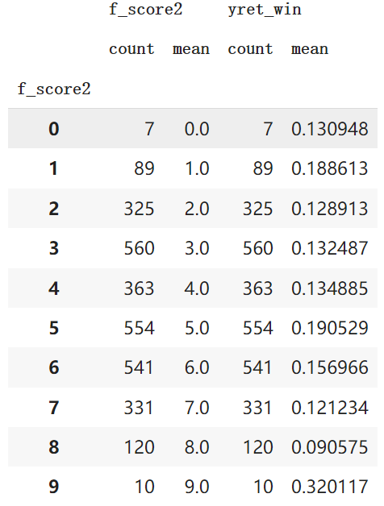

Table 4.9

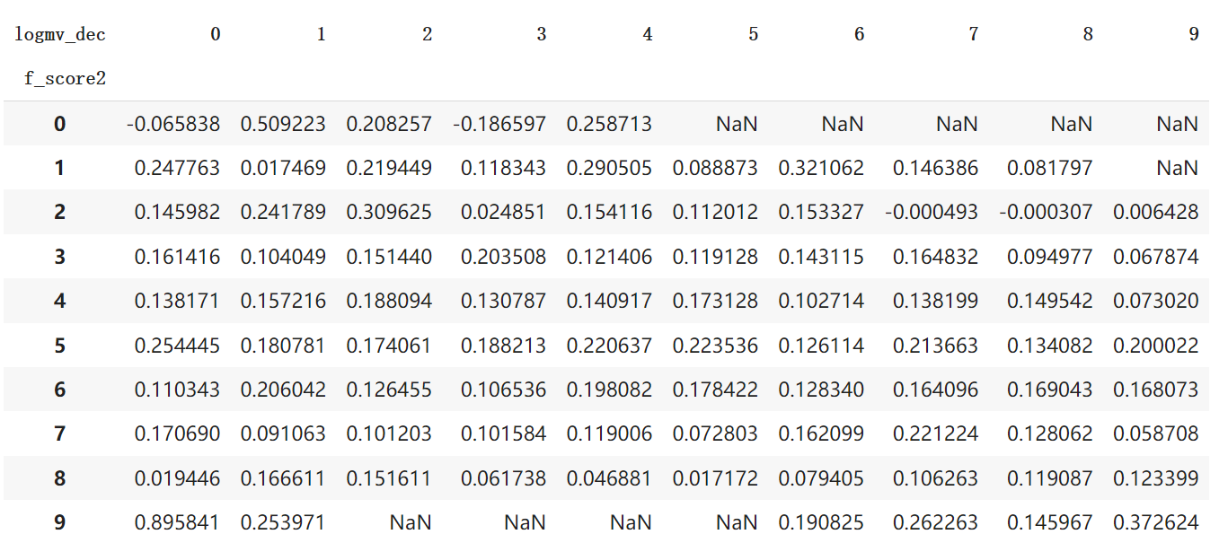

Table 4.10

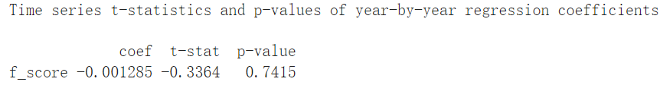

[

Table 4.11

Table 4.12

Table 4.13

Table 4.14

**Table Z-1 Statistical Description**

|  |  |
| --- | --- |
| **count** | 15807 |
| **mean** | 6.235707 |
| **std** | 8.320291 |
| **min** | 3.518620 |
| **25%** | 2.676905 |
| **50%** | 3.879413 |
| **75%** | 6.662449 |

**Z-1 Distribution of Mean Z-scores by Company Market Size**

**Table Z-2 Z score vs Market Size – Stock Return**



**Table Z-3 Z score(truncated) vs Market Size – Stock Return**



**Table Z-4 Z label vs Market Size – Stock Return**



**Table Z-5 Z label(truncated) vs Market Size – Stock Return**



**Z-2 Regression Result I**

**Z-3 Regression Result II**

Table 4.13

Table 4.14

Table 4.15

Table 5.1

Table 5.2

Table 5.3

Table 6.1

Table 6.2

Table 6.3

Table 6.4

Table 6.5

Table 6.6

# **Reference List**

Altman, E. I. (1968). Financial Ratios, Discriminant Analysis and the Prediction of Corporate Bankruptcy. *The Journal of Finance*, *23*(4), 589–609. https://doi.org/10.2307/2978933

Fama, E. F., & French, K. R. (1992). The Cross-Section of Expected Stock Returns. *The Journal of Finance*, *47*(2), 427–465. https://doi.org/10.1111/j.1540-6261.1992.tb04398.x

Frankel, R., & Lee, C. M. C. (1998). Accounting valuation, market expectation, and cross-sectional stock returns. *Journal of Accounting and Economics*, *25*(3), 283–319. https://doi.org/10.1016/S0165-4101(98)00026-3

Piotroski, J. D. (2000). Value Investing: The Use of Historical Financial Statement Information to Separate Winners from Losers. Journal of Accounting Research, 38, 1–41. https://doi.org/10.2307/2672906

Sloan, R. G. (1996). Do Stock Prices Fully Reflect Information in Accruals and Cash Flows about Future Earnings? The Accounting Review, 71(3), 289–315.

Woodley, M. K., & Jones, S. T. (n.d.). Value Stocks and Accounting Screens: Has a Good Rule Gone Bad?

Lee, W.-J., & Zhang, Y. (2014). Accounting valuation and cross-sectional stock returns

in China. *China Accounting and Finance Review, 16*(2),

Frazzini et. al. (2018): Andrea Frazzini, David Kabiller, Lasse H. Pedersen, “Buffett’s

alpha,” Financial Analysts Journal, Vol. 74 No. 4 (2018), pp.35-55